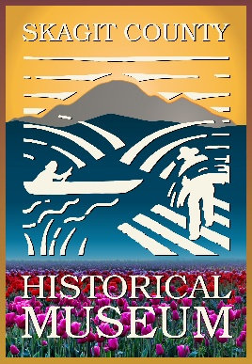
Leave a Lasting Legacy
Support Skagit County Historical Museum Through Planned Giving
Thank you for considering a planned gift to the Skagit County Historical Museum. Your generosity helps preserve the stories, artifacts, and heritage that define our community—ensuring future generations can connect with Skagit County’s rich past. We would be honored to work with you as you explore options for creating a meaningful legacy.
Please note: We are not tax or legal professionals. We encourage you to consult with your financial or legal advisor when making planned giving decisions.

What Is Planned Giving?
Planned giving allows you to make a thoughtful, future-focused contribution—often through your estate plans—while aligning your philanthropic goals with your financial and family priorities.
These gifts provide long-term sustainability for the Museum, helping us continue to educate, inspire, and preserve Skagit County history for years to come.

Common Planned Giving Options
- Bequest – Include the Museum in your will or trust
- Beneficiary Designation – Name the Museum as a beneficiary of a retirement account, life insurance policy, or other asset
- Charitable Gift Annuity – Provide income to you or a loved one during your lifetime, with the remainder benefiting the Museum
- Donor-Advised Fund (DAF) – Recommend a future gift through your fund

Why Make a Planned Gift?
A legacy gift to the Skagit County Historical Museum:
- Preserves local history for future generations
- Supports exhibits, collection care, and educational programs
- Creates a lasting tribute of your commitment to the community
- May provide financial or tax benefits depending on your plan

Give Today Through Your IRA
Qualified Charitable Distributions (QCDs)
If you are age 70½ or older, you may be able to make a Qualified Charitable Distribution (QCD) directly from your Individual Retirement Account (IRA) to the Skagit County Historical Museum.
A QCD allows you to:
- Support the Museum immediately—no need to wait to make a legacy gift
- Satisfy all or part of your Required Minimum Distribution (RMD)
- Reduce your taxable income, as the distribution is typically excluded from your gross income
- Make a meaningful impact without affecting your cash flow
This is a simple and tax-efficient way to support the preservation of Skagit County history while meeting your financial goals. We recommend consulting your financial advisor to determine if a QCD is right for you.

Consider Your Giving Goals
As you explore your options, you may wish to reflect on:
- Would you like your gift to support a specific program or need?
- Do you prefer to give anonymously or be recognized?
- How would you like your legacy to reflect your connection to Skagit County?
We would love to learn about your wishes so we can honor your generosity and ensure your gift is used as you intend.

Let’s Start the Conversation
If you have questions or would like to discuss your plans, please reach out:
Jo Wolfe
Skagit County Historical Museum
📞 360.466.3365
Email: jwolfe@co.skagit.wa.us
We look forward to connecting with you and helping you create a meaningful and lasting impact.

Important Note
The Skagit County Historical Museum does not provide legal or tax advice. Please consult a professional advisor when making financial decisions.

